5/10/2021

EROL A’NIL

South Metropolitan TAFE

Movie Database Project

RAD Project - Team Elite

# Contents

Contents i

Sprint One 1

Source Control Screenshot 1

Analysis Report 3

Business Rules for Software Development 3

Introduction 3

Project Scope 3

Glossary Terms 3

Business Rules 4

Movie Website Navigation Chart 4

CITE Managed Services Quality Assurance 5

Organisational Roles 5

CITE Coding Standards 6

CITE Quality Assurance 6

Quality Objective 6

Quality Objective 6

Testing Goals 7

Acme Entertainment Pty Ltd Development Requirements 7

Adaptive Design 8

Description 8

Advantages 8

Disadvantages 8

Responsive Design 9

Description 9

Advantages 9

Disadvantages 9

Project Selection 10

Test Plan 10

1.0 Sprint One 11

Introduction 11

Rapid Application Development (RAD) and Workflow Diagram 11

Scrum Testing Strategy 11

Scope 12

Out of Scope 12

Quality Objective 12

Quality Objective 12

Testing Goals 13

Roles and responsibilities of each team member 13

Scrum Master: EROL A’NIL 13

Developement Team : NATHAN TIE , BLAKE TOPHAM 13

Test Methodology 14

Overview 14

Bug Triage 14

Confirm new bugs 14

Prioritise confirmed bugs 14

Solve inconsistencies 14

Review stale/in-progress bugs 14

Review prioritised bugs 14

Suspension Criteria and Resumption Requirements 15

Suspension Criteria 15

Resumption Criteria 15

Test Completeness Check 15

Resource & Environment Needs 15

Testing Tools 15

Test Levels 16

**Test Levels define the Types of Testing to be executed on the Application Under Test (AUT).** 16

Constraints: 16

Test Environment 16

Integration Testing 17

Consistency Validation Report 18

# 

# Sprint One

## Source Control Screenshot

Link: <https://github.com/profiteroles/RAD>

Screenshot:

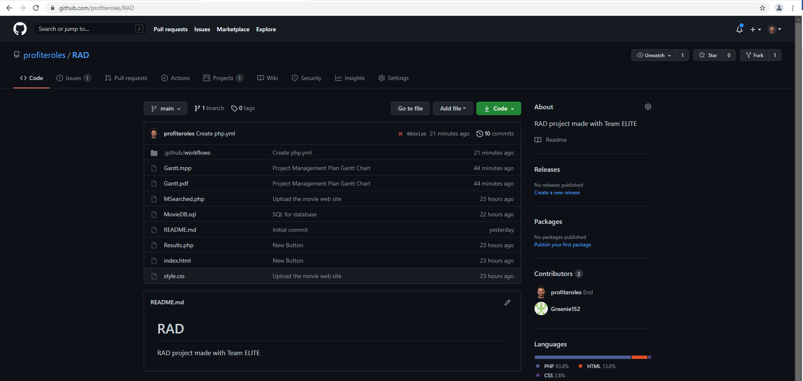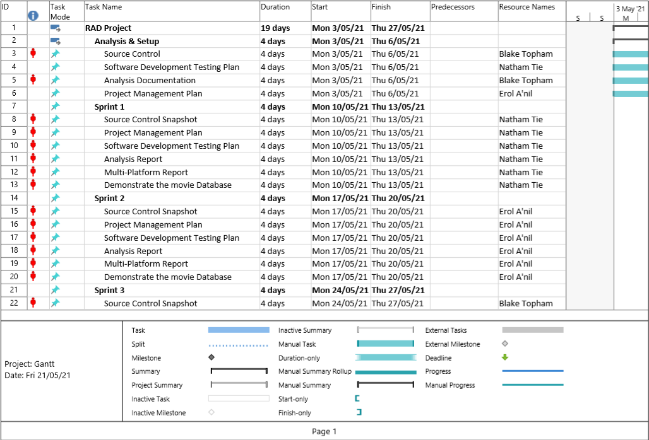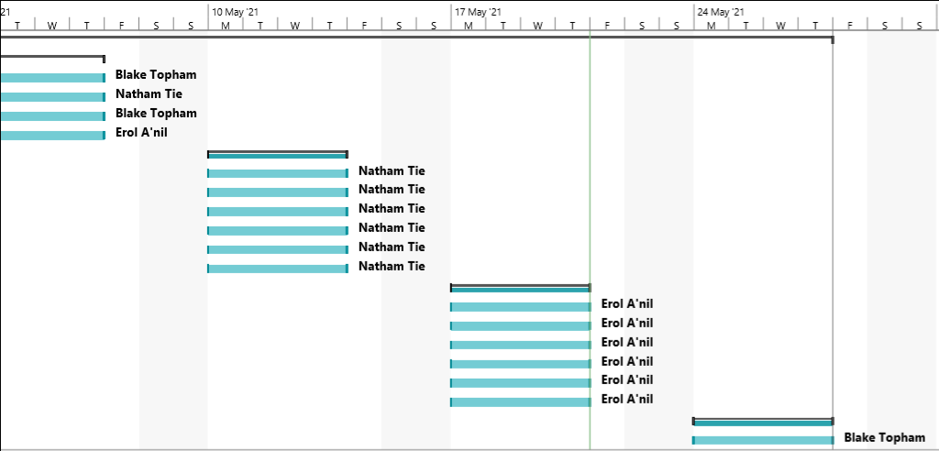

## Analysis Report

### Business Rules for Software Development

### Introduction

CITE Managed Services develops software for a range of clients and from time to time they will utilise external contractors when appropriate. CITE has sought to employ The MisSprints developers to implement a Movie Database for Acme Entertainment Pty Ltd. The directive is to adopt sprint workflow to develop each set of user requirements.

This project will be overlooked by Mr Stewart Godwin, Product Owner and liaison Consultant for CITE Managed Services.

### Project Scope

The project that this documentation is for, is a movie database that allows users to search and view movies. Each movie will display the movie’s information that is fetched from the database. The movie database website to be able to display on all the major digital platforms.

### Glossary Terms

These are the following terms that may be used in the following documentation, any new terms will be added throughout the duration of the project.

Database – Stores all data and information needed for the application.

Software Development Lifecycle – a method in which the developing team follows to go step by step through the project’s life until completion.

Input- information that gets entered into the computer by the user.

Web Browser – a application that connects to the internet and displays websites.

Digital Platforms – these are devices that display digital items such as computers, mobiles, tablets.

### Business Rules

These are the following rules of how the product works and how the user interacts with it.

1. The website must work on different web browsers, eg Chrome, Firefox Microsoft Edge.
2. The website must be able to display correctly and smoothly on different device screens, such as tablet, mobile, desktop.
3. Input is needed to allow the user to search for a movie in the database.
4. If no input is entered, no movies will be displayed.
5. The user cannot search for multiple movies using more than one keyword.
6. The user cannot edit or change any movie details other than rating the movie.
7. The user must be able to favorite their movies and add to their list.

### Movie Website Navigation Chart

TODO : Blake Chart

## 

## CITE Managed Services Quality Assurance

### Organisational Roles

We, Team Elite a small team of 3 that are working with CITE Managed Services.

**Scrum Master:** EROL A’NIL

**Development Team:** BLAKE TOPHAM, NATHAN TIE

Detail description of the Roles and responsibilities of different team members like

Scrum Master is the facilitator of the Scrum- the lightweight framework of Agile framework. Scrum master act as coaches the team.

Test Manager is responsible for the test effort’s success by advocating, resource planning a management and resolution of the issues that impede testing. This encompasses the following:

* Negotiate purpose and deliverables of testing
* Planning and management of test resources
* Assessing testing progress
* Advocating the quality of testing by quantifying defects
* Advocate appropriate level of testability in the software development process

Developers is responsible for the following

* Creating and implementing the source code for new applications
* Testing and debugging the source code
* Evaluate applications and update with suitable modifications
* Develop technical handbook to represent design code
* Create digital software interface that entices the user into a seamless interaction between the client and the application

### CITE Coding Standards

Coding standards are collections of coding rules, guidelines, and best practices. To allow easy flow of coding styles, a guideline must be put in place for an organisation.

Common Aspects of CITE Coding Standard:

• Naming Conventions  
• File Naming and Organization  
• Formatting and Indentation  
• Comments and Documentation  
• Classes, Functions and Interfaces  
• Pointer and Reference Usage  
• Testing

All systems and projects will be covered by the following ISO standards.

ISO/IEC/IEEE 12207:2017 Systems and software engineering — Software life cycle processes

### CITE Quality Assurance

CITE Managed Services performs quality assurance throughout the entire software development lifecycle as regular quality testing is done at every stage of the way. CITE standards are to use a variety of test types to ensure the project enjoys in-depth quality assurance.

Some test styles we have included in this weeks Sprint 1 are;

* Integration Testing
* System Testing
* Acceptance Testing

### Quality Objective

**Reference:**

**ISO 9001:2005: International standard that specifies requirements for a quality management system (QMS)**

### Quality Objective

* To Establish protocl between the application, application design and development _ what are the expectations from the website
* Empower Quality Assurance to have the application development proritize between fixing old bugs and developing new features

### Testing Goals

* Ensure the Application Under Test (AUT) conforms to functional and non-functional requirements
* Ensure the AUT meets the quality specifications defined by the client
* Ratio of Testcases conducted to th eapplication requirements are >1. Hence requirements are to be known to the entire team written to testcases executed should be 1 or approaching close to 1
* Be informed that the quality gols are determined by the production management, developers, QA as a team
* Ratio of testcases
* Bugs/issues are identified and fixed before go live

## 

## Acme Entertainment Pty Ltd Development Requirements

The requirements given by ACME Entertainment are;

1. Index page contains navigation bar, frequently top 10 searched from most frequently searched to lesser of the 10 and footer.
2. Movies will be categorized by genre, collections or popular.
3. Popular movie titles will be numbered by most searched, in the Popular section page.
4. Search page will contain search fields for the movie title, genre, rating and year.
5. Search page will display search results and include how many search results.
6. Search page will allow user to select on result movie titles which will direct them to that selected movie’s information page.
7. Search form must allow user to search by any combination of search inputs, whether it is all search field inputs or part’s of.

For example;

Title, genre, rating and year

Title, genre and year

Genre and year

Genre

1. Movie information page will include the movie poster, trailer, rating and details.
2. Website must be able to adapt to multiple device screen sizes.

## 

## Adaptive Design

### Description

Adaptive design refers to the creation of websites that operate within static thresholds for display resolution, known as the viewing context. The viewing context of the target device is assessed and a set of stylings are applied accordingly to the elements of the web page.

### Advantages

The main advantage of adaptive design is the final presentation of the webpage’s display is much more predictable during development. This is due to the elements being sized according to a selected fixed layout, determined by the screen’s resolution.

Adaptive designs can be made applicable to older devices that do not support responsive designs.

### Disadvantages

Adaptive design is limited to the static definitions of resolutions defined by the developer. As the webpage is loaded, and the resolution is assessed, a pre-determined layout is selected appropriately. Adaptive design has limitations here bound by the definitions of the developer.

Once a webpage is loading, adaptive layout selection is no longer applied. For example, in modern devices where it is possible to scale the resolution of the web browser on screen, the webpage will not adapt its design to a modified screen resolution after the page has loaded.

## Responsive Design

### Description

Responsive web design refers to the creation of websites using dynamically sized elements that are responsive to their parent containers, and ultimately the display resolution.

### Advantages

Responsive design is extremely flexible in its rendering approach. The designs are fluid are able to display responsively to any viewing context, in contrast to adaptive design’s fixed layout approach.

Statistics show that more than half of the global internet traffic (52+%) is from a mobile device (Hosting Tribunal, 2020). As mobile devices continue to be produced in various shapes and sizes, responsive designs gain an advantage of dynamically adapting to these devices.

Responsive designs achieve higher site rankings by search engines like Google or Yahoo!, therefore leading to more web traffic.

Responsive designs can reduce the need, and therefore the cost of, developing a separate mobile-friendly version of the website.

### Disadvantages

Site navigation can become more challenging to keep consist with responsive designs. As the screen size decreases, so too do the elements portraying the navigation paths.

Responsive web designs can also take longer to load than adaptive designs. This is due to their relative nature where the elements are sized in relation to the size of the parent elements. Longer loading times can often leading to a bad browsing experience on the user’s behalf.

Older browsers, or older devices who are limited with software, may not be compatible with responsive designs and will therefore show incorrectly.

## Project Selection

For this project we have chosen a hybrid design incorporating both Responsive and Adaptive approaches in order to maximise the benefits of both approaches.

Responsive design will provide an overall better look and feel (user experience) to the finished product and result in a higher Search Engine Optimization ranking. The majority of elements will be designed to be responsively sized and placed.

However, to maintain a broad support of different screen resolutions certain structural elements will have to be altered in order to conserve a functional user interface across large changes in resolution. This is where adaptive design will apply appropriate page layouts and stylings to particular structural elements such as the navigation menu in order to prevent un-intended visual phenomena or inhibition of the user interface.

# Test Plan

|  |  |  |  |
| --- | --- | --- | --- |
| Version | Change Date | By | Description |
| 1.0 | 13/05/2021 | BLAKE TOPHAM |  |
| 1.1 | 17/05/2021 | NATHAN TIE |  |
| 1.2 | 24/05/2021 | EROL A’NIL |  |
| 1.3 | 30/05/2021 | ALL |  |

## Sprint One

### Introduction

### Rapid Application Development (RAD) and Workflow Diagram

RAD is an effective software development standard. Under circumstances wher eth einitial requirements are not clear or where requiements changes frequently takes place during the development, RAD provides a systematic software system that has the ability to be automated.

Sufficient sotware testing is required when producing software application of high quality. Classical testing methods are not ideal for iterative development like RAD. Hence, there is a need for tailored testing method for this development standard.

Assumptions: To adopt a testing stratgey we shall assume that RAD is

|  |  |
| --- | --- |
| * Iterative – includes Sprints * Isevolutionary – continuous development of the application with improvements * Contains the familiar technical RAD language | * Library facilities and data retrieval capabilities * Implemented code is from a high level language * Support environment is sophisticated |

### Scrum Testing Strategy

The following tests are performed on the software to ensure the application stands up to the QA standards of CITE

|  |  |
| --- | --- |
| * Complexity check * Quality Testing * Performace Testing | * Usability Testing * Unit Testing |

### Scope

CITE Managed Services develops software for a range of clients and from time to time they will utilise external contractors when appropriate. CITE has sought to employ The MisSprints developers to implement a Movie Database for Acme Entertainment Pty Ltd. The directive is to adopt sprint workflow to develop each set of user requirements.

This project will be overlooked by Mr Will E Coyote, Product Owner and liaison Consultant for CITE Managed Services.

The developer team has an established Scrum Master who shall allocate work the team memembers that are wihtin the scope of the first sprint.

Features of the application:

* The SMT Movie Rental provides 2300 movies for renting to the customers
* The prototype is in a visual format with navigation hierarchy established
* The application can be navigated to search for a movie record using the Movie Name, Genre, Rating and year of release
* The application also gives information on Top 10 of most searched movies

### Out of Scope

1. Secure login
2. Authorization: In case of lost credentials, there is no secured way of accessing the customer file to reset the confidential password
3. Multimedia auto loading into the thumbnails
4. User reviews

### Quality Objective

**Reference: ISO 9001:2005: International standard that specifies requirements for a quality management system (QMS)**

### Quality Objective

* To Establish protocl between the application, application design and development _ what are the expectations from the website
* Empower Quality Assurance to have the application development proritize between fixing old bugs and developing new features

### Testing Goals

* Ensure the Application Under Test (AUT) conforms to functional and non-functional requirements
* Ensure the AUT meets the quality specifications defined by the client
* Ratio of Testcases conducted to th eapplication requirements are >1. Hence requirements are to be known to the entire team written to testcases executed should be 1 or approaching close to
* Be informed that the quality gols are determined by the production management, developers, QA as a team
* Ratio of testcases

Bugs/issues are identified and fixed before go live

### Roles and responsibilities of each team member

### Scrum Master: EROL A’NIL

## Developement Team : NATHAN TIE , BLAKE TOPHAM

Scrum Master is the facilitator of the Scrum- the lightweight framework of Agile framework. Scrum master act as coaches the team.

Test Manager is responsible for the test effort’s success by advocating, resource planning a management and resolution of the issues that impede testing. This encompasses the following:

* Negotiate purpose and deliverables of testing
* Planning and management of test resources
* Assessing testing progress
* Advocating the quality of testing by quantifying defects
* Advocate appropriate level of testability in the software development process
* Developers is responsible for the following
* Creating and implementing the source code for new applications
* Testing and debugging the source code
* Evaluate applications and update with suitable modifications
* Develop technical handbook to represent design code
* Create digital software interface that entices the user into a seamless interaction between the client and the application

### Test Methodology

### Overview

This project employs the Rapid Application Development (RAD) methodology. This means testing occurs within every iteration (sprint) of the software development cycle. As this project has been structured to carry out weekly sprints, the testing will also occur as frequently.

### Bug Triage

The goal of the triage is to provide framework and structure for the process of eliminating bugs or issues within the software as it is being developed.

### Confirm new bugs

Confirm the presence or absence of a newly reported bug. Attempt to re-create the bug in simulated conditions.

### Prioritise confirmed bugs

Prioritise all existing bugs based on their severity level. The chart below will provide a guide as how to classify bugs.

### Solve inconsistencies

Gather any further required information regarding an existing bug and improve understanding.

### Review stale/in-progress bugs

Review any bug fixes currently in production, prioritising those that have not any recent progression.

### Review prioritised bugs

Assess each individual bug, devising possible solutions and documenting any restrictions.

### Suspension Criteria and Resumption Requirements

They are the criteria for any disruption to the testing process and workflow.

### Suspension Criteria

Testing for a particular functionality is to be suspended once a bug has been identified. Sub-sequential behavior cannot be deemed reliable for testing once bugged methods are used.

### Resumption Criteria

Testing for particular functionalities can be resumed once any identified bugs have been corrected by the developers.

### Test Completeness Check

Here you define the criterias that will deem your testing complete.

For instance, a few criteria to check Test Completeness would be

* 100% test coverage – Check in alignment with the requirements (frontend+backend)
* 100% code quality coverage
* User Acceptance testing coverahe – 100%
* All Manual & Automated Test cases executed
* All open bugs are fixed or will be fixed in next release

### Resource & Environment Needs

### Testing Tools

The following tools are required to test the software:

* A modern web browser (Such as Google Chrome or Mozilla Firefox)
* A text editor (Such as VS Code or Notepad++)
* A code cleaner (Such as PHPCodeSniffer)

**Test Environment**

Below outline the minimum hardware requirements that will be used to test the Application.

* [No minimum requirements]

The test environment is required to have one of the following operating systems installed:

1. Windows 10
2. Android Jellybean
3. Mac OS X

### Test Levels

### **Test Levels define the Types of Testing to be executed on the Application Under Test (AUT).**

1. Integration Testing
2. Testing by combining
3. Test for data flow
4. System Testing
5. Check for compliance as per requirements
6. Over interaction of components (Load, performance, reliability and security testing)
7. Optional check for non-functional requirements testing – on demand
8. Acceptance Testing
9. Check against requirement specification at deployment/delivery
10. Involve customer and other stockholders to run this testing process

### Constraints:

Time constraint : Delivery date for Sprint 1 presentation to the client scheduled for June 5th 2020

### Test Environment

It mentions the minimum hardware requirements that will be used to test the Application.

|  |  |
| --- | --- |
| Memory: 16GB | Processor: i7 10th Gen Intel 10950, 2.4GHz |

Following software’s are required in addition to client-specific software.

|  |  |
| --- | --- |
| 1. Windows 10, iOS 2. MS Office 3. VS Code 4. NotePad++ | 1. Google Chrome 2. MS Edge 3. Mozilla Firefox 4. MS Excel |

### Integration Testing

Table goes here

### Consistency Validation Report

Table goes here